LOW CODE
Zoho Creator
EXPERIMENT 6
NAME : ANIRUDH R ROLL NO : 240701039

DELUGE SCRIPTING

AIM
To write Deluge scripts in Zoho Creator using variables, operators, conditional statements, loops, collections, custom functions, record operations (fetch, insert and update) and sendmail in the “Student Crop Advisory System” application, and to execute them and view the outputs.

SOFTWARE / TOOLS USED
- Zoho Creator (Low-Code Application Development Platform) with the Deluge script editor
- Student Crop Advisory System application (created in Ex. 3)
- Web browser (Google Chrome / Microsoft Edge) and a valid email id to receive the mail

THEORY
Deluge (Data Enriched Language for the Universal Grid Environment) is the scripting language of Zoho Creator. It has an English-like syntax and is used to add business logic to an application without writing full-fledged code. Deluge scripts are written in the script editor of a workflow and run on the server.
Deluge scripts run when an event occurs. The form events used in this experiment are:
- On Load: runs when the form is opened. Used to set default values, or to enable, disable, hide and show fields.
- On User Input: runs when the user changes the value of a field. Used for auto-filling and live calculations.
- On Validate: runs when Submit is clicked, before the record is saved. Used to check the data and to stop the submission using cancel submit.
- On Success: runs after the record is saved. Used to update other records, insert records and send emails.
The main parts of Deluge used here are variables and data types (text, number, decimal, date), operators, if-else conditions, for each loops, collections such as List, the input keyword (to read and set the field values of the form), alert (to display a message), data access tasks (fetch, insert into and update) and the integration task sendmail. A custom function is a reusable block of Deluge code that accepts arguments and returns a value; it is created once and can be called from any workflow.

PROGRAMS IN THIS EXPERIMENT

No. | Deluge concept | Form and event
1 | Variables, operators, string and date functions | Student_Query – On Load
2 | Setting a field value and disabling a field | Student_Query – On Load
3 | Conditional statements (if – else if) and cancel submit | Student_Query – On Validate
4 | Fetching a record and auto-filling fields | Student_Query – On User Input of Crop
5 | Custom function with arguments and return value | Function calcFertilizer, called from Student_Query – On User Input of Land_Area_Acres
6 | Insert a record (insert into) | Student_Query – On Success
7 | Update a record | Advisory – On Success
8 | Sending an email (sendmail) | Advisory – On Success
9 | Collections and for each loop | Advisory – On Load
10 | Aggregate function count() to avoid duplicate records | Student_Query – On Validate

PROCEDURE
- Open the application: Open the “Student Crop Advisory System” application in edit mode. Make sure that a few records are available in the Crop_Master form (for example Rice – Cereal – Kharif – Alluvial).
- Create the helper form: Create a new form “Notification_Log” with the fields Message (Multi Line) and Logged_On (Date-Time). It is used in Program 6.
- Create the custom function: Go to Workflows → Functions → New Function. Enter the function name calcFertilizer, select the return type as float, add the arguments float area and string category, click Create Function and paste the code of Program 5.
- Write the workflow: For every other program, go to Workflows → Form Workflow → Create, select the form and the event given in the program, open the Deluge script editor (free flow scripting), paste the code and click Save.
- Run and capture: Click Access Application, open the form in live mode, perform the action given in the program and take a screenshot of the output. Disable the workflow of Programs 1 and 9 after taking their screenshots, since their messages appear every time the form is opened.

Program 1: Sort the Array

Code:
SortedMarks = MarksList.sort()

Output:
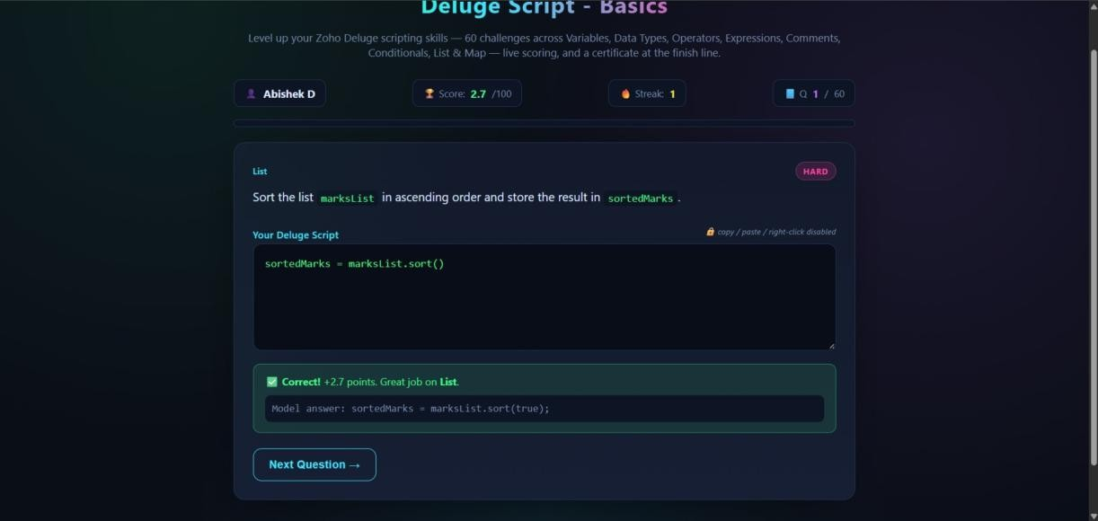

Program 2: Find size of the array

Code:
Totalsubject = subject.size()

Output: Screenshot 2:
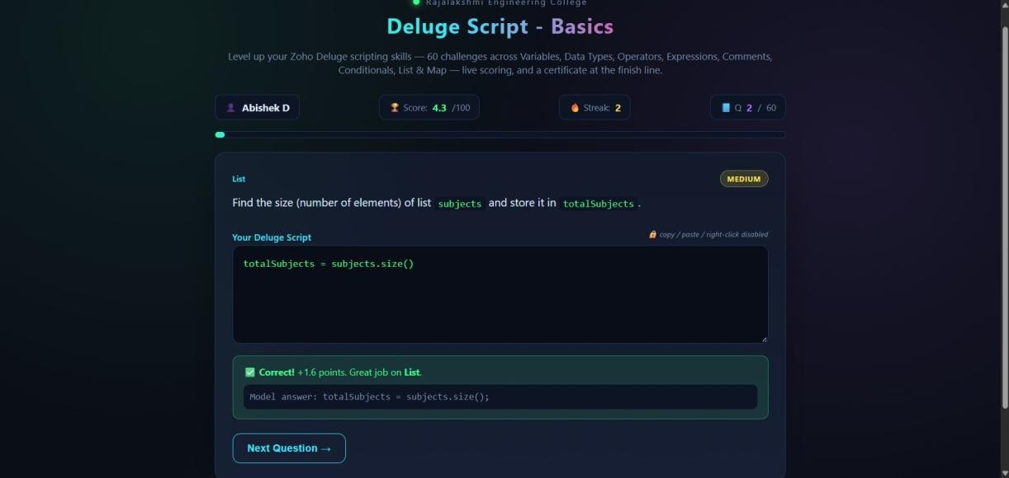

Program 3: Boolean value

Code:
HasScholarship = false
.Screenshot 3: Output of Program 3 – Validation alert for an invalid land area
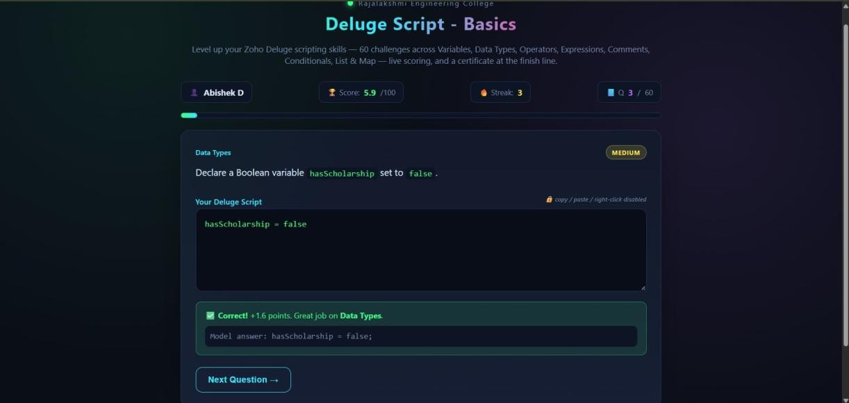

Program 4: Declare a variable Code:
Result = null

Output:
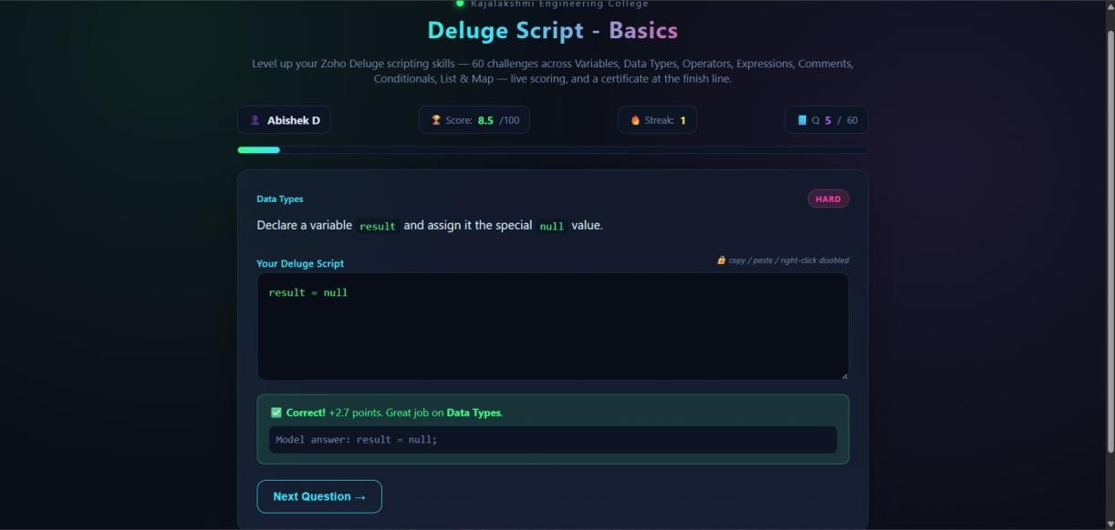

Program 5: Swap the values Code:
Temp = x x=y y=temp

Output:
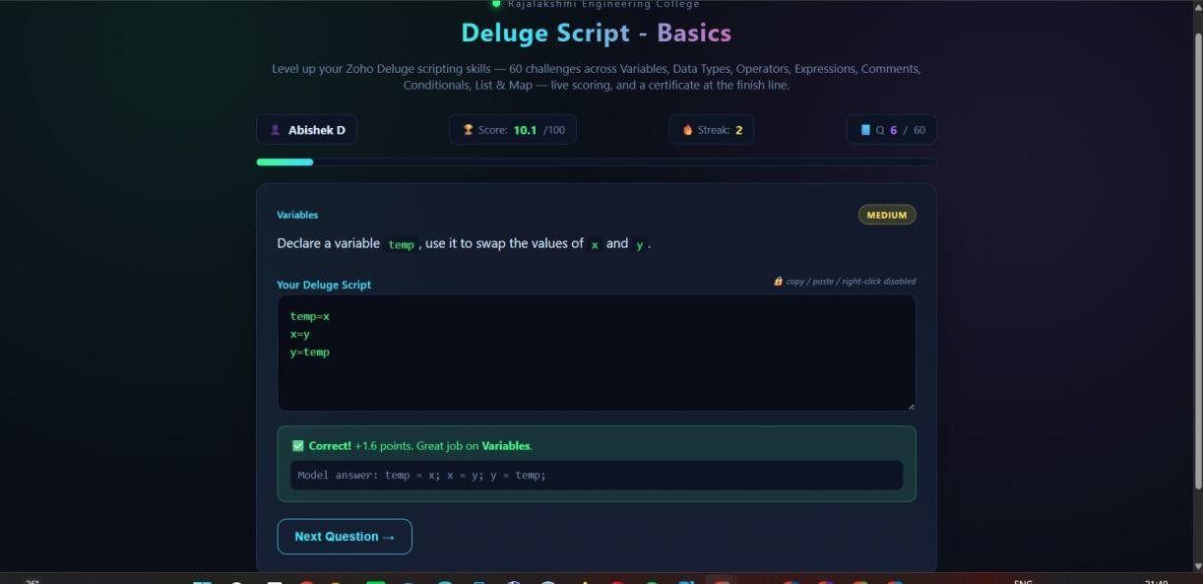

Program 6: Get All the key of the List

Code:
StudentKeys = student.getKey()

Output:
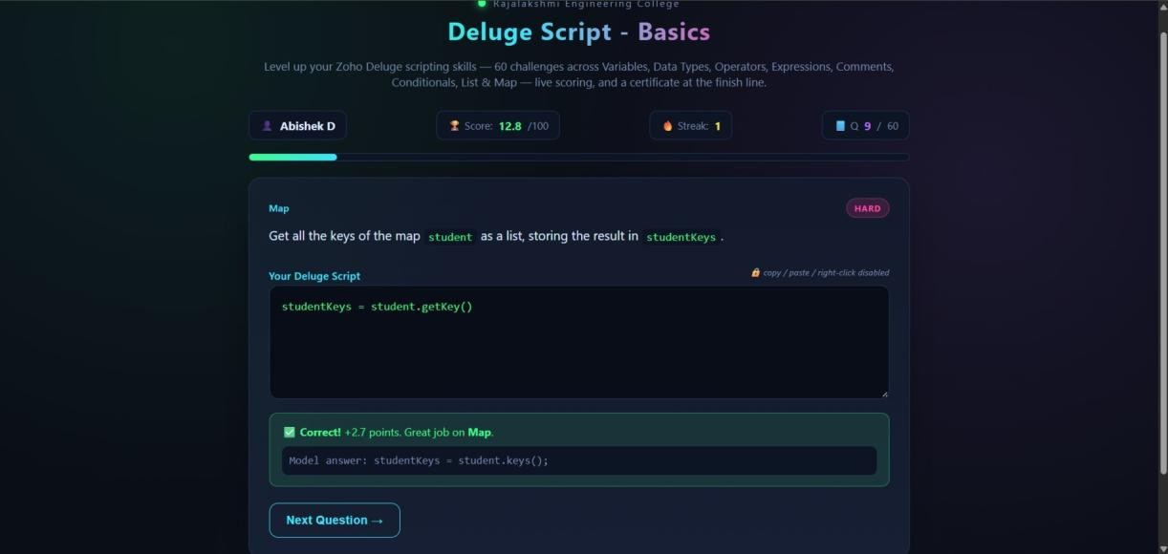

Program 7: Find the Remainder Code:
Remainder = num%2

Output:
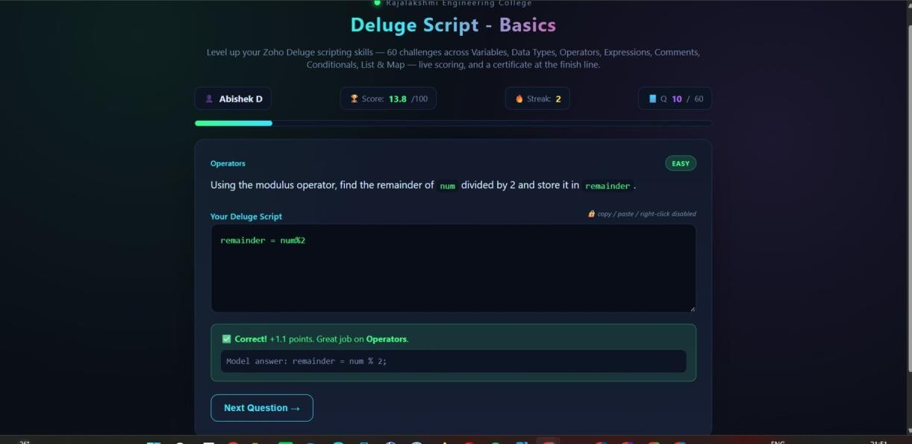

Program 8: Find the Average Code:
Average = (m1+m2+m3)/3

Output:
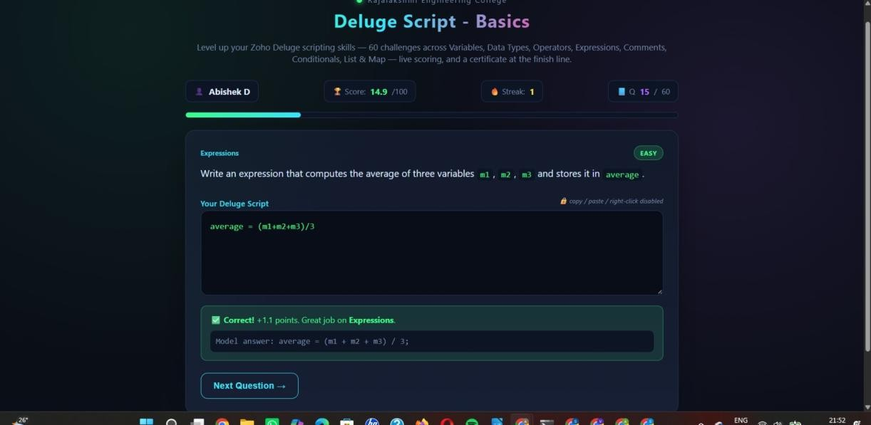

Program 9: Reassign the Values Code:
Score = 20

Output:
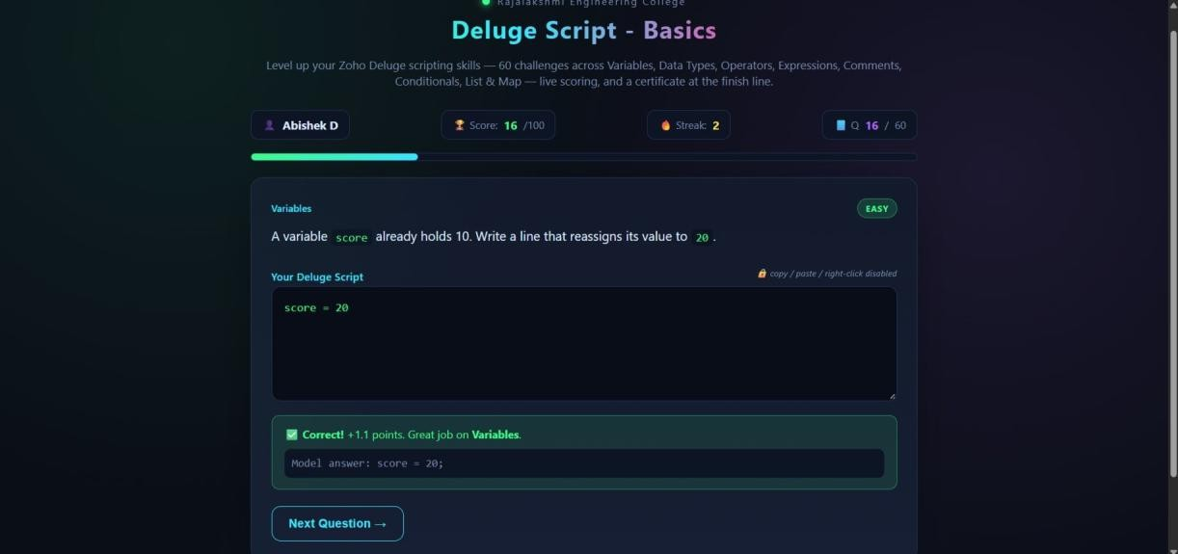

Program 10: Expression using paranthesis Code:
Output = (a+b)*c

Output:
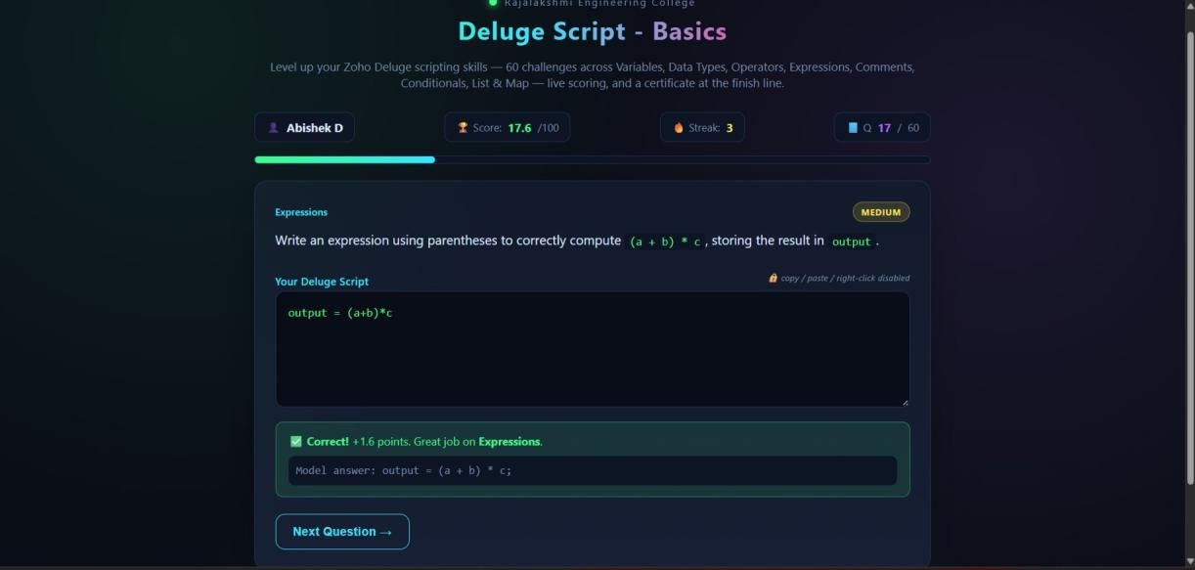

RESULT
Thus, Deluge scripts using variables, operators, conditions, loops, collections, a custom function, record operations (fetch, insert and update) and sendmail were written in the “Student Crop Advisory System” application in Zoho Creator, and the outputs were verified successfully.

